Metoda One vs. All:

Marime set de antrenare: 15935

Kernel Liniar:

|  |  |  |  |
| --- | --- | --- | --- |
| Acuratete | MSE | Nr. med. iteratii | Nr. med. vectori suport |
| 80.81% | 5.35 | 8327.52 | 1625.13 |

Matrice de confuzie testare:

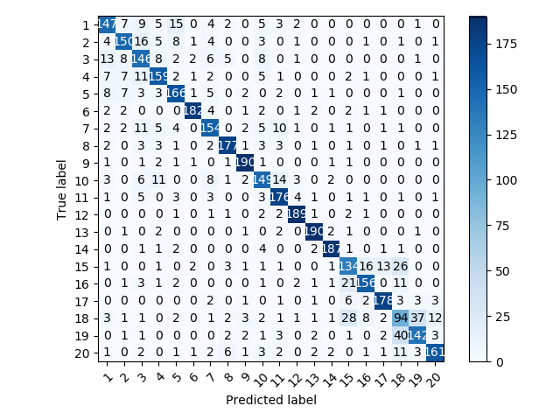

Matrice de confuzie antrenare:

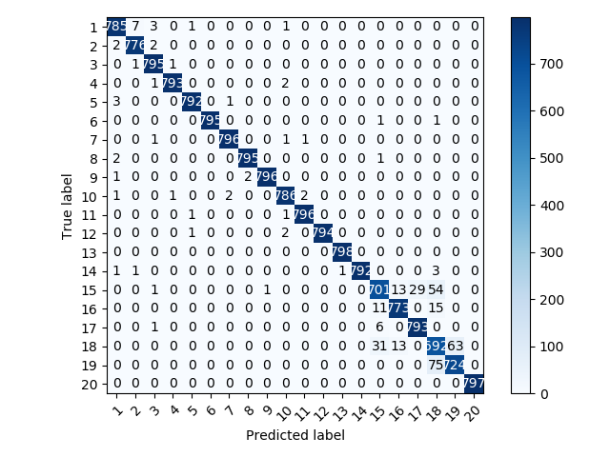

Kernel Polinomial:

Grad = 2

|  |  |  |  |
| --- | --- | --- | --- |
| Acuratete | MSE | Nr. med. iteratii | Nr. med. vectori suport |
| 78.16% | 6.30 | 7707.16 | 2694.17 |

Matrice de confuzie testare:

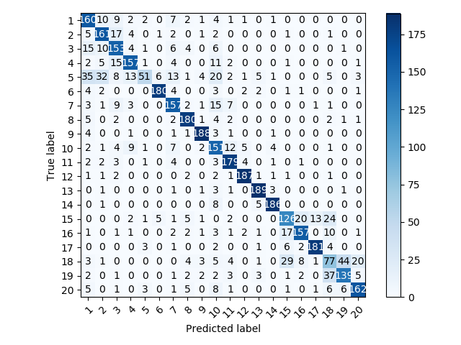

Matrice de confuzie antrenare:

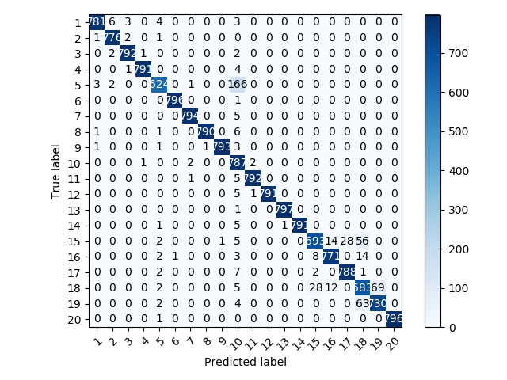

Kernel Gaussian:

Gamma = 0.005

|  |  |  |  |
| --- | --- | --- | --- |
| Acuratete | MSE | Nr. med. iteratii | Nr. med. vectori suport |
| 80.94% | 6.09 | 5862.16 | 3763.67 |

Matrice de confuzie testare:

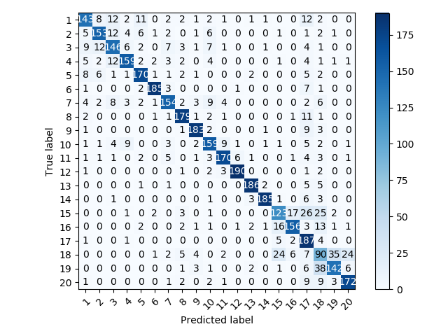

Matrice de confuzie antrenare:

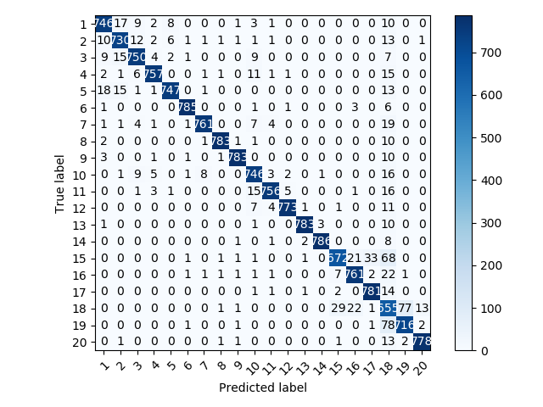

Kernel Sigmoid:

Gamma = 0.5

|  |  |  |  |
| --- | --- | --- | --- |
| Acuratete | MSE | Nr. med. iteratii | Nr. med. vectori suport |
| 19.93% | 44.38 | 1152.62 | 1079.61 |

Matrice de confuzie testare:

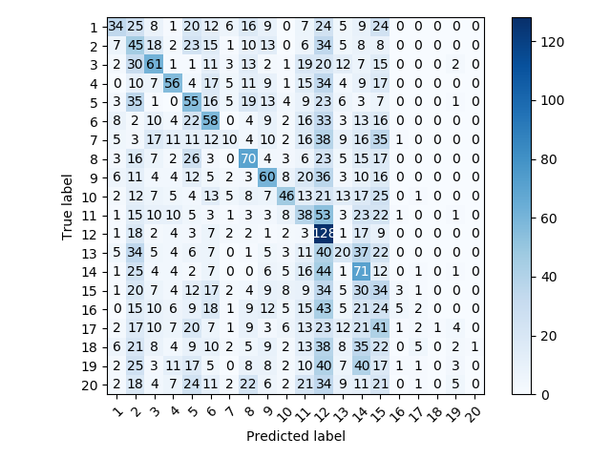

Matrice de confuzie antrenare:

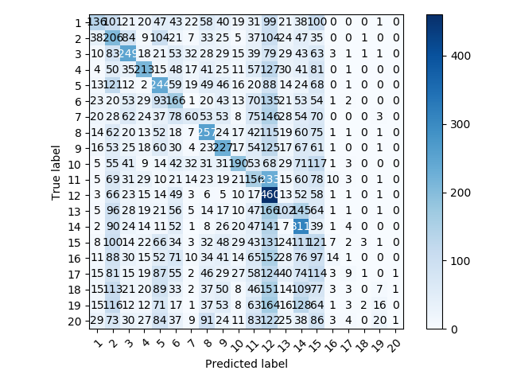

Metoda One vs. One:

Marime set de antrenare : 15935

Kernel Liniar:

|  |  |  |  |
| --- | --- | --- | --- |
| Acuratete | MSE | Nr. med. iteratii | Nr. med. vectori suport |
| 76.73% | 6.62 | 1350.99 | 443.72 |

Matrice de confuzie testare:

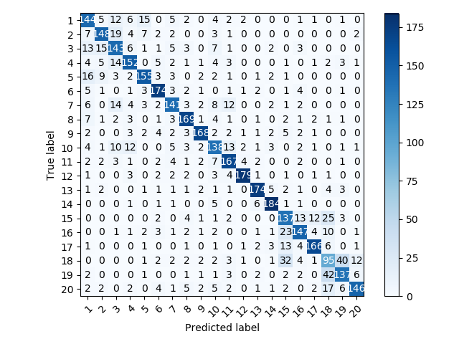

Matrice de confuzie antrenare:

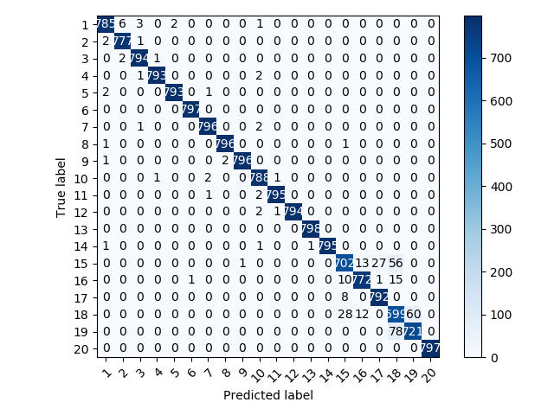

Kernel Polinomial:

Grad = 2

Gamma = 0.005

|  |  |  |  |
| --- | --- | --- | --- |
| Acuratete | MSE | Nr. med. iteratii | Nr. med. vectori suport |
| 40.17% | 20.23 | 1236.3 | 1246.09 |

Matrice de confuzie testare:

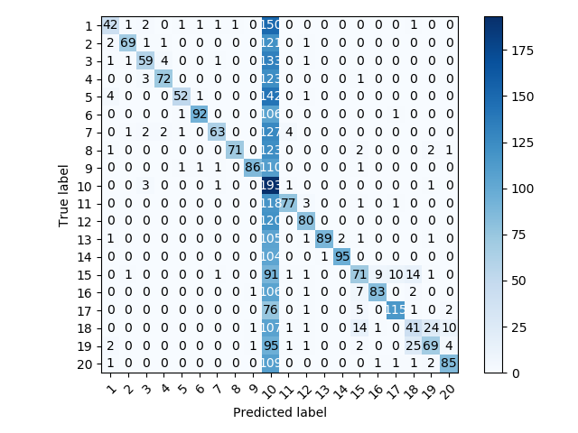

Matrice de confuzie antrenare:

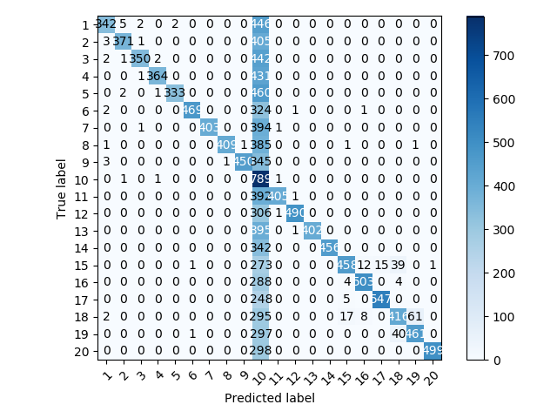

Kernel Gaussian:

Gamma = 0.005

|  |  |  |  |
| --- | --- | --- | --- |
| Acuratete | MSE | Nr. med. iteratii | Nr. med. vectori suport |
| 74.43% | 11.27 | 1372.59 | 1011.77 |

Matrice de confuzie testare:

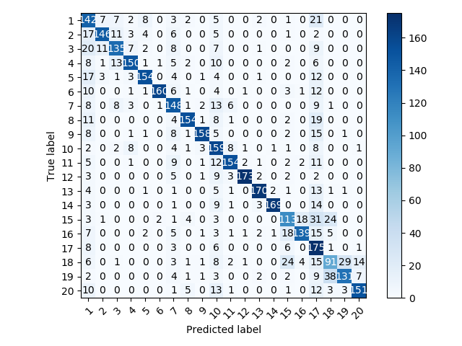

Matrice de confuzie antrenare:

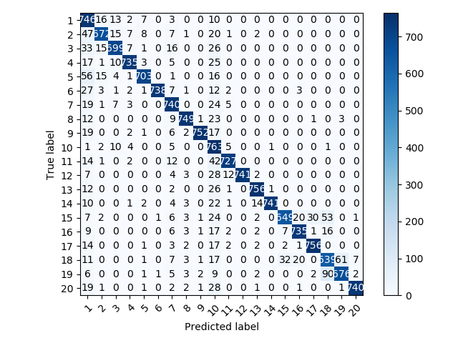

Kernel Sigmoid:

Gamma = 5

Coef0 = 2

|  |  |  |  |
| --- | --- | --- | --- |
| Acuratete | MSE | Nr. med. iteratii | Nr. med. vectori suport |
| 23.79% | 50.84 | 590.68 | 991.395 |

Matrice de confuzie testar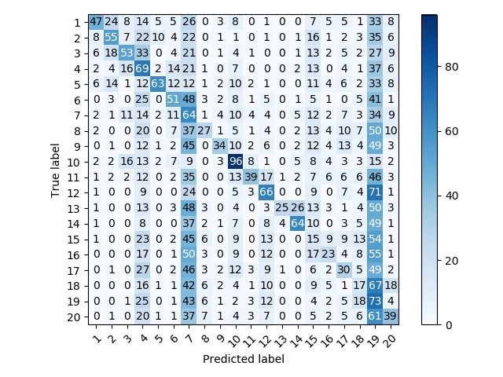

Matrice de confuzie antrenare:

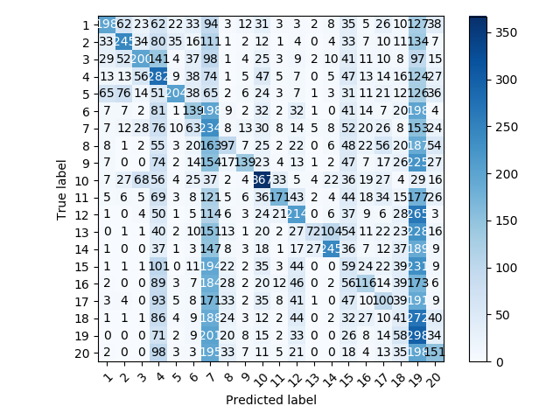

Kernelul liniar si cel Gaussian au avut cele mai bune rezultate (~80% acuratete).